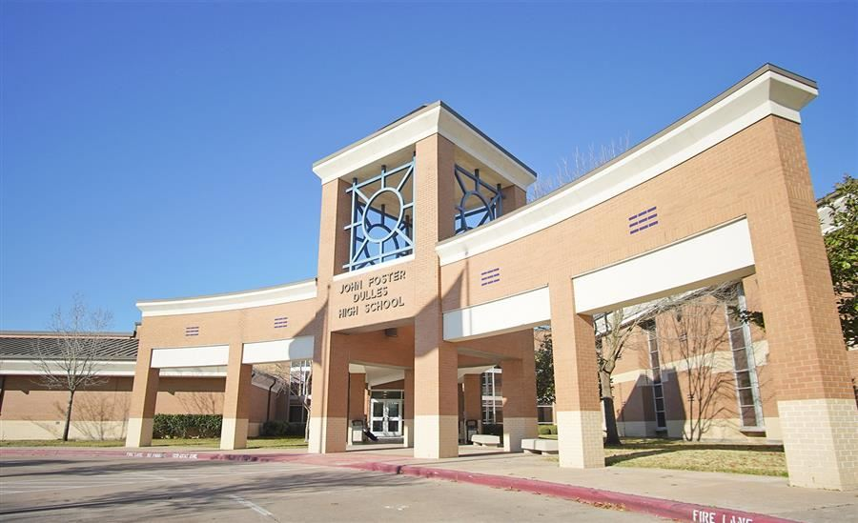

FORT BEND INDEPENDENT SCHOOL DISTRICT

FORT BEND INDEPENDENT SCHOOL DISTRICT



JOHN FOSTER DULLES HIGH SCHOOL

550 Dulles Avenue, Sugar Land, TX 77478

Phone: (281) 634-5600 Fax: (281) 634-5682

www.fortbendisd.com/dhs

Twitter: @DHS_Vikings

**School District and Community**

John Foster Dulles is the flagship school out of the eleven high schools total in the Fort Bend Independent School District. Opened in 1959, Dulles currently serves students from several areas including the cities of Meadows Place, Missouri City, and Sugar Land. Located in the northeast part of Fort Bend County just southwest of Houston, ours is a community whose strengths lie in a diversity of cultural, ethnic, and socioeconomic groups.

**School Information**

* 2025-2026 School Year - Seniors: 504, Juniors: 542, Sophomores: 548, Freshman: 609
* Faculty: 144 teachers – 44.3% have Masters degrees and beyond
* Schedule: Classes meet approximately 50 minutes per day, 7 periods per day, 5 days each week, 18 weeks per semester.
* School Year: August 12, 2025 to May 28, 2026
* Accreditation: Southern Association of Secondary Schools and the Texas Education Agency

**CURRICULUM**

* Dulles provides a strong academic program with more than 200 possible course selections including an extensive vocational/technical curriculum and options to earn college credit during the school year through 31 Advanced Placement courses, 6 On Ramps courses and 2 Dual Credit courses.
* UIL-sponsored athletic programs are offered in football, basketball, tennis, track, soccer, golf, swimming, volleyball, baseball, softball and cross-country.
* Co-curricular programs include choir, band, orchestra, drill team, student government, service and academic clubs, athletics and Academic Decathlon and Destination Imagination.
* The Gifted and Talented program offers courses in English, Math, Science, Social Studies, Foreign Languages, and Fine Arts.
* Dulles has been home to the FBISD Math & Science Academy since 2010. Bringing students that are interested in mathematics and science together from all parts of FBISD allows us to offer a unique high school experience where students have access to math and science curricula typically not available until the university level.
* Instruction is available for special needs through Special Education and Bilingual/ESOL instruction.

**2025-2026**

**PRINCIPAL**

Corey Stewart

**ASSOCIATE PRINCIPAL**

Nancy Thomas

**ASSISTANT PRINCIPALS**

Deanna Eiland

Jorge Garza

Sarah Morvant

Alan Thompson

**LEAD COUNSELOR**

Amy Garrey

**COUNSELORS**

Angela Ball

Nicola Ballard

Chastity Rubin

LaDale Webster

**COLLEGE & CAREER ADVISOR**

Kasha Williams

**CAMPUS ASSESSMENT COORDINATOR**

Allison Pike

**REGISTRAR**

Amnelis Melendez

**CEEB | ACT and SAT School Code**

446785

Dulles Information

**ETHNIC DISTRIBUTION**

Asian 38.94%

African American 20.65%

Hispanic 22.68%

White 13.21%

Two or More Races 3.88%

American Indian 0.42%

Native Hawaiian or Pacific Islander 0.23%

**COLLEGE ADMISSIONS TESTING**

**SAT English DHS TEXAS**

2022-2023 574 497

2021-2022 570 506

2020-2021 553 505

**SAT Math DHS TEXAS**

2022-2023 578 482

2021-2022 581 496

2020-2021 564 498

**ACT English/Math DHS TEXAS**

2022-2023 26.1/26.7 18.8/18.9

2021-2022 26.7/26.9 19.2/19.3

2020-2021 27.2/27.5 19.6/19.3

**ACT COMPOSITE DHS TEXAS**

2022-2023 26.5 19.2

2021-2022 26.9 19.5

2020-2021 27.0 20.0

**NATIONAL MERIT SCHOLAR PROGRAM**

Class of Commended Semi-Finalist

2025 33 22

2024 37 23

2023 51 31

2022 52 18

2021 33 17

**POSTSECONDARY COMMITMENT**

***Source: National Student Clearinghouse Data on Class of 2023 who enrolled***

***in postsecondary education during the first year following high school graduation.***

***(Class of 2023 initial enrollment data will be available from NSC in November 2024)***

**Class of 2023**

Total Postsecondary Enrollment

During First Year: 80%

Four Year College 57%

Two Year College 23%

**2024 – 2025 ADVANCED PLACEMENT PROGRAM**

Total AP for all student students taking 1 or more AP exams

Number of Exams 1913

AP Students with Scores of 3+ 1715

% of Total AP Students with Scores 3+ 90%

|  |  |  |  |
| --- | --- | --- | --- |
| **Graduation requirements and programs**  The Foundations+ Endorsements credits for the 2023-2024 graduating seniors: | | | |
| 4 credits English  *ELA I, II, III, IV or one credit in any authorized advanced English Course* | 4 credits Math  *Algebra I, Geometry, two credits in any authorized advanced math course* | 4 credits Science  *Biology, IPC or Chemistry or Physics, and two credits in any authorized science course* | 3 credits Social Studies  *US History, Government (.5 c), Economics (.5 c), World Geography or World History* |
| 2 credits World Language or Computer Science | 1 credit Physical Education | 1 credit Fine Arts | 6 credits in electives  *May include CTE or certification courses* |
| .5 credits Speech (FBISD) | .5 credit Health (FBISD) | *Credit requirements specific to at least one endorsement* | |

|  |  |  |  |
| --- | --- | --- | --- |
| **Grading system** | | | |
| * All high school credit courses attempted are included in the calculation of the GPA | | | |
| * The GPA system utilized in FBISD is referred to as the “100 Point Scale” | | | |
| * GPA is calculated by adding semester averages earned and dividing by semesters attempted | | | |
| * Courses are weighted differently in GPA calculations | | | |
| * Grade points are assessed based on the grade and level as follows: | | | |
| Letter & Numerical Grades | | Advanced Placement/ Beyond AP/ | AAC/Honors courses |
| A | (100-90) | Dual Credit | 5 Point GPA Weight |
| B | (89-80) | 10 Point GPA Weight |  |
| C | (79-70) |  |  |
| F | 69 & Below |  |  |